Practical 13

1, The length of SODM_HUMAN is 222 amino acid.

It is found in the mitochondrion matrix. There is an entry page where I can find a download pattern through which I could successfully download the sequence in FASTA format.

2， 250 results found in UniProtKB

The range of the percentage identity of these retrieved alignments is from 58.1-100.

For SODM_MOUSE, the range of the percentage identity of these retrieved alignments is from 57.3 to 100. The best alignment is SODM_RAT, 95%

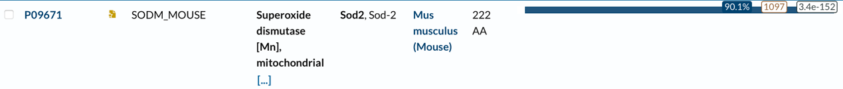

The meaning of the residues highlighted in blue means same amino acids, while the gray means different.

Random Protein Sequence results

>random sequence 1 consisting of 222 residues.

EKVYNSIFSGVINTWPIHGMYEYMEKAYEYEVIKHTSNGTDAMQFYRMVQGGYPPQSQIF

VDQEIIEWAHLKNGFDDACAIMMCGIVQSKKLVHEILRGTTDGNPGLEVKRHSDPLWTCN

VQWVMTNFESFNSEPDTRGDLGMMCCVFVIYPQEKNPLGAMEAEFQTQYVTHSRPHSEYK

QYAPACWCTKWVHIMGKGFNPKPTSSSENCVSDEYASGTDQL

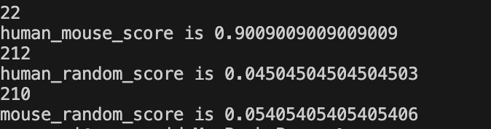

Our human and mouse similarity is 90.1%, by our own program. Approximately the same as online blast.